PART – 5 : Modularized ML Web Application
Iris Flower Classification Using Streamlit

In this part of the project, a Streamlit web application was developed to predict Iris flower species using trained Machine Learning models. The user enters sepal and petal measurements and the application predicts the species of the Iris flower.

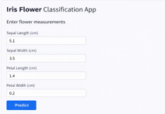
Figure 1: Application Interface.

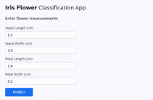
Figure 2: User Input Measurements.

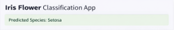
Figure 3: Prediction Output Displayed.

Result:
The Streamlit web application successfully predicts Iris flower species based on the measurements entered by the user.

